NLTE CONFERENCE
Athens, Greece 7-11 December, 2009

RESERVATION FORM

Dear Participant,
We are pleased to inform you that the above mentioned meeting will take place at the Athens Electra Palace Hotel.
Please fax this form directly to the central Reservations Department of Electra Hotels & Resorts before November 20th, 2009 otherwise your request will be subject to hotel’s availability.
Reservations Department: FAX: 0030 210 3241871 E-mail: salesepath@electrahotels.gr

FIRST NAME: …………………………..…………………………………………………………….….

LAST NAME: ………….………………..…………………………………………………………….….

ARRIVAL DATE: …………………..…………... DEPARTURE DATE: ………………………..…….

COMPANY: ………………………..……………… TITLE: ……………………………………………

ADDRESS: …………………..……………………………………………………………..……………

TEL: …………………………FAX: ……………..……… E-mail: ……………………………............

ROOM TYPES:
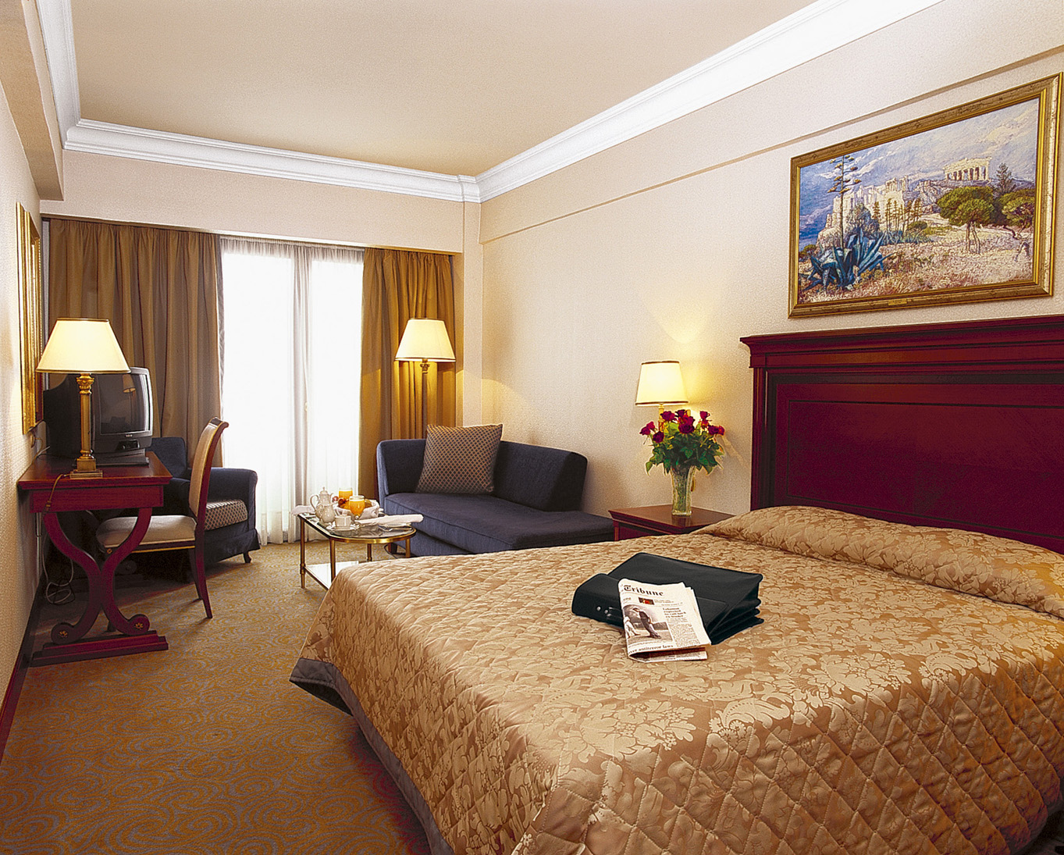
Please tick the room type you prefer to book.

Single Room: € 135,00

Double Room: € 140,00

Non smoking room request:

Special Requests: ………………………………………………………...……………………………

GUARANTEE POLICY:
We require a credit card number with expiry date as a guarantee

CREDIT CARD Number: ………………………………………………………………….……………

EXPIRY DATE: ………………………………………..……………………….……..…………………..

CANCELLATION POLICY:
No cancellations fees are applied if cancellation is received up to 4 days prior to arrival in written notice. For reservations cancelled within the 3 days prior to arrival or non -shows, the hotel shall be entitled to charge cancellation fees of 1night’s stay.

SIGNATURE: ……………………………………….. DATE: …………………..………….….

